

USER’S MANUAL

TagMotion

Your Music Collection Organizer

August, 2009
USER'S MANUAL

1.0 GENERAL INFORMATION 4
1.1 Motivation 4
1.2 License 4
1.3 Thanks 5
1.3.1 Scott Wheeler 5
1.3.2 Brian Weeres 5
1.3.3 Tango Team 5
1.3.4 Global Noises 5
2.0 SYSTEM DESCRIPTION 7
2.1 System Overview 7
2.2 System Configuration 8
2.2.1 Source & Destination Directory 9
2.2.2 File Structure 9
2.2.3 Info File Types 10
2.2.4 Sort Collection 10
2.2.5 Dummy Creation 10
2.2.6 FreeDB Query 10
3.0 GETTING STARTED 13
3.1 Reading the Source Directory 13
3.1.1 Drag & Drop 14
3.2 ID3 Tag Editing 14
3.2.1 Changing Tags of a Song 14
3.2.2 Changing Tags of a Record 15
3.2.3 Changing Tags of the Collection 16
3.2.4 AutoTag Function 17
3.2.5 FreeDB Query 18
3.2.6 Embedding Images 20
3.2.7 Extracting Images 21
3.3 Filter 22
3.4 Save Collection 23
3.5 Copy Song / Record / Collection 24
3.6 Delete File / Record 24
4.0 SUMMARY 26

1.0 GENERAL INFORMATION

GENERAL INFORMATION

1.1 Motivation

The reason for starting this software was to organize a music collection. The aim was to create a comfortable to use tool for ID3-Tag editing and file copying. Batch processing should a main point in this software.

Following main features are implemented:

- Batch ID3-Tag editing for a directory that represents a record
- ID3-Tag filling by using the file- and directory name (AutoTag)
- ID3-Tag filling by requesting the CDInfo from the FreeDB
- Copying the complete record (or just single files) with renaming the files dependent on a user-specified file structure
- Batch embedding images into the ID3-Tags
- Extracting images that are stored in the ID3-Tags to disc
- Filter for the record collection to find simply records by certain properties
(e.g. > 300 Kbps, Artist = “...”, Duration < 20 min, etc.)
- Handling of other information files in the record directory
(Cover Art, *.cue- or *.txt-files, etc.)

1.2 License

TagMotion is licensed under the GNU license.
All sources can be changed, but I cannot give a warranty for all the functionality.
It is tested as much as possible.

1.3 Thanks

1.3.1 Scott Wheeler

TagMotion also uses the open .Net Library “TagLib” from Scott Wheeler to implement tagreading and tagwriting. Thank you very much, Scott, awesome library. (http://developer.kde.org/~wheeler/ )

1.3.2 Brian Weeres

TagMotion uses an algorithm of Brian Weeres to query CD Infos from freedb.org to fill missing record information. Thanks to you, Brian. (http://www.codeproject.com/Members/Brian-Weeres )

1.3.3 Tango Team

The great icons in TagMotion are taken from the Tango Desktop Project. (http://tango.freedesktop.org/ )

1.3.4 Global Noises

Another big thank goes to the Global Noises Community, because without its support this software wouldn't be there, where it is today. Thx, Noisy.

2.0 SYSTEM DESCRIPTION

SYSTEM DESCRIPTION

2.1 System Overview

Following Screenshot shows you an overview after starting the software.

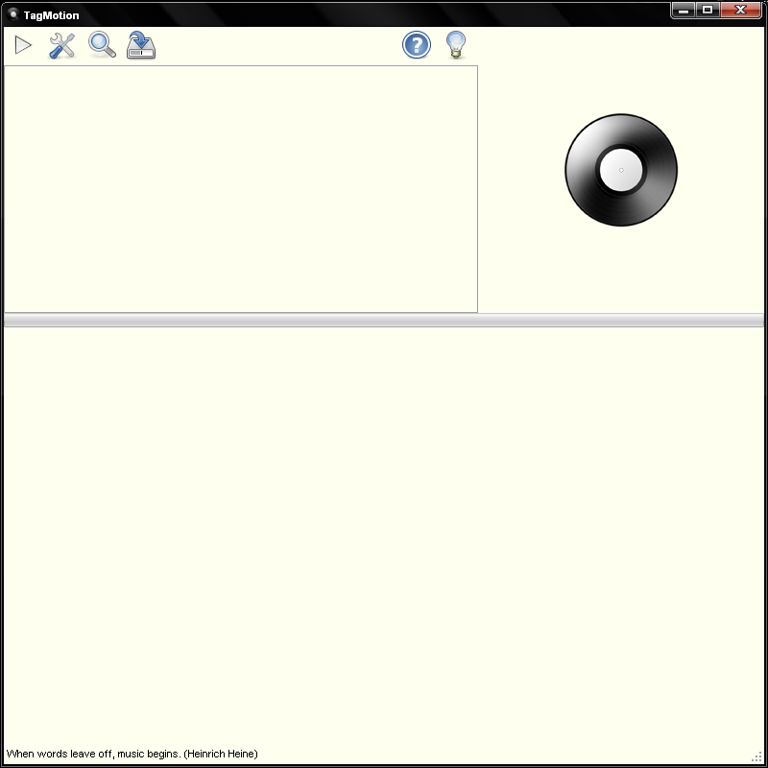

 | Starts reading the Source Directory.  All Subfolder of the specified directory will be read, too.
 | Opens the Settings Dialog Box.  System Configuration can be done here.
 | Opens the Filter Dialog Box.  Search function for the collection.
 | Opens the FileSave Dialog for saving the collection information.  The collection can be saved as html-, txt- or xml-file.
 | Opens the Quick Help Dialog.  Main functions are explained here shortly.
 | Opens the About Box.

2.2 System Configuration

By opening the Settings Dialog, the following Box appears:

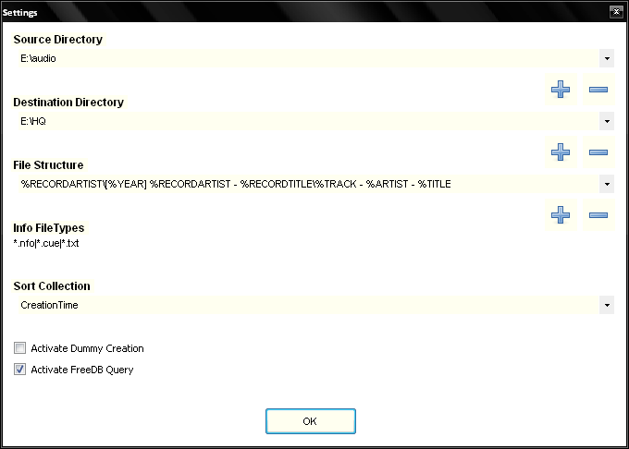

2.2.1 Source & Destination Directory

The combo-boxes for the Source- and Destination-Directory and the File Structures can have multiple values. You can add or delete values by using the plus and minus on the right side under the chosen combo-box.
The Source- and the Destination-Directory define from where the music should be copied.

2.2.2 File Structure

The File Structure defines the structure for renaming the files during the copy process.
If you choose a File Structure like in the screenshot

%RECORDARTIST\[%YEAR] %RECORDARTIST - %RECORDTITLE\%TRACK - %ARTIST - %TITLE

the following directory will be created:

%RECORDARTIST | Represents the Artist of the Record, may differ from the Artist of a Track.  For example in a compilation “Various Artists”.
%RECORDTITLE | Represents the Title/Name of the Record.
%ARTIST | Represents the Artist of the Track,.
%TITLE | Represents the Title of the Track
%TRACK | Represents the Track Number
%YEAR | Represents the Release Year of the Record
%LABEL | Represents the Publisher/Label of the Record
%RELEASE | Represents the CatalogueNumber (Cat#) of the Record
%GENRE | Represents the Genre of the Record
%BITRATE | Represents the average Bitrate of the Record (not the Track!)
%DIR | Represents the Original Directory Name of the Record.  Some people need it, but usually it's not needed. =)

During Copying, all the images the Record Directory contains, will be copied, too.
Following filetypes are supported: Jpg, Jpeg, Gif & Png.
The File Structure for the images is similar to the File Structure of a track, except that the Track Artist is replaced by the Record Artist and the Track Title is replaced by the Record Title. If there are more than one image in the directory, the images get a counter.

2.2.3 Info File Types

You have to specify any other filetypes, you want to handle, in the Info File Types textbox.
You have to keep the structure “*.[extension]|*.[extension]”, e.g. “*.cue|*.txt|*.nfo”.
The File Structure for those files is similar to the File Structure of a track, except that the Track Title is replaced by “Info”. If there are more than one info file in the directory, the files get a counter, for example “Info 2”, “Info 3”, etc.

2.2.4 Sort Collection

Here you can choose the order for sorting the records in the Treeview. By default, Path or CreationTime is the best. But if you scan already full-tagged directories, you might want to sort the collection by Artist or any other property.

2.2.5 Dummy Creation

If you check the “Activate Dummy Creation” checkbox, you disable the copying. Instead of copying the files, dummy files (0 KB) will be created. The advantage of this function is, that you can test different File Structures very fast and easily with it. If you have found your personal preferred File Structure, you wont need this function anymore and you can uncheck the checkbox.

2.2.6 FreeDB Query

If this function is enabled, during the reading process of the Source Directory, TagMotion starts queries for records, that doesn't have valid tags. If a record has valid tags depends on your specified File Structure. For example, if a File Structure doesn't contain the expression “%Genre”, because you don't want the genre name in your filenames, this tag wont be checked to validate the correctness of the tags.
Of course, you can start queries after reading the Source Directory in the Treeview, too. Disabling this function decreases the duration of the reading process. For larger Source Directories, this could be an advantage.

3.0 GETTING STARTED

GETTING STARTED

3.1 Reading the Source Directory

After reading the Source Directory, the Treeview will be filled with all the information and the properties of the collection is shown in the PropertyGrid.

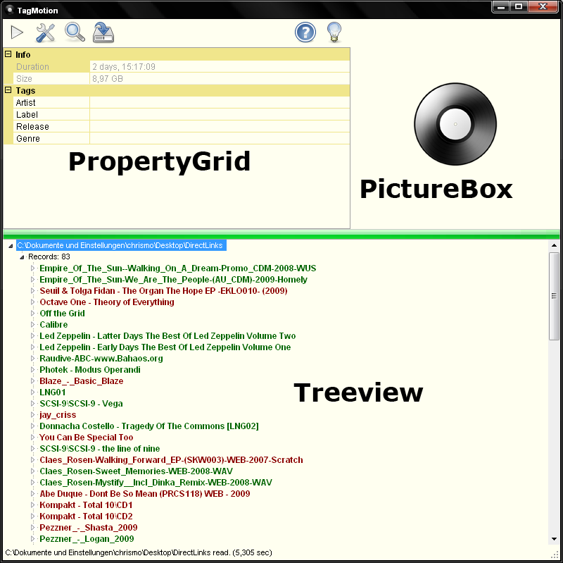
The properties of the selected item of the Treeview is showed in the PropertyGrid. If you select a Record, the properties of the Record is shown, if you select a Song or a Picture, its properties are shown.
The different colors of the Records in the Treeview show, if the tags of the Record is completely filled or not. Just to repeat, only those tags are checked, that are contained in the File Structure.

3.1.1 Drag & Drop

You can also drag and drop ONE directory into the Treeview, the dropped directory will be you Source Directory.

Note: The dropped directory will NOT be added to your Source Directory list.

3.2 ID3 Tag Editing

3.2.1 Changing Tags of a Song

Open the Record Node in the Treeview and select the Song. After selecting the Song, its properties can be viewed in the PropertyGrid.

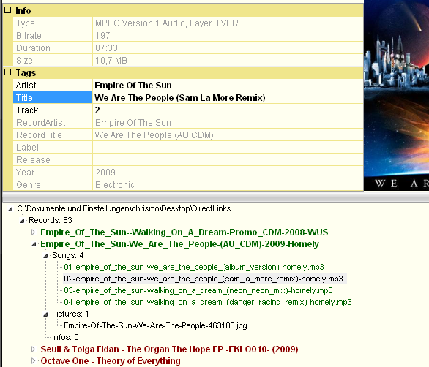
Now you can change the Song related properties like Song Artist (%ARTIST), Song Title (%TITLE) or Track Number (%TRACK). All other properties belong to the record itself and can only be changed there.

Note: If you select a Song and you can see a Picture in the Picture Box, the music file contains this
image in its tags.

3.2.2 Changing Tags of a Record

If you select the directory of the Record in the Treeview, you can edit all tags of the including music files at once.
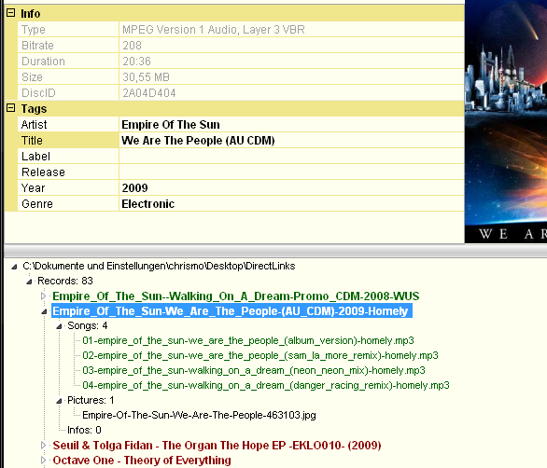

For example, if you change the Genre of the Record, ALL the tag properties of the Record will be changed and saved in ALL music files immediately.

Note: If you select a Record and you can see a Picture in the Picture Box, the first image file in the
directory is shown.

Note: Because of the missing ID3 standard for the Catalog Number, I used the comment tag field for
the Release property. So don't be surprised, when you find strange strings in the Release Field.

3.2.3 Changing Tags of the Collection

If you select the Collection Node in the Treeview, you cannot only see the common properties like Size or Duration of your Collection, you can see also editable Tag Fields. They can be used to change ID3 tags of all Records in you Collection.

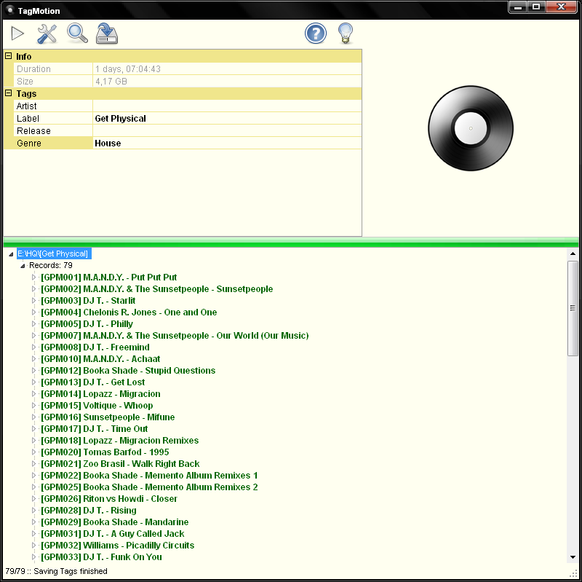
This can be useful for complete label collections or artist collections. The release field doesn't seem to make sense first, but you can use it for example to fill the fields with a constant string like here “GPM0”.

Note: If you change ONE property of the Collection, only THIS tag will be changed and saved in ALL
music files immediately.

3.2.4 AutoTag Function

If you Right-Click on a Record, you can find the AutoTag Function. This function helps you to fill the tags from the filename of the music files.

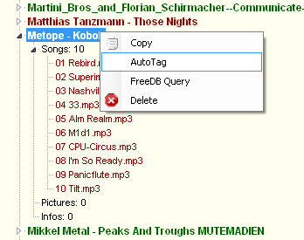

If you select the AutoTag Function, following Dialog Box appears to request the File Structure of the Record.

In the Textfield you'll see the first Song of the Record. Now you have to replace the items by the File Structure Constants.

After confirmation, the tags of the music files will be filled and saved.

3.2.5 FreeDB Query

You can also start a request to the database of FreeDB to get the CDInfo for the Record. The DiscID that is needed will be calculated from the music files in the directory.

If one or more entries could be found, you'll be prompt to select the CDInfo from the list.

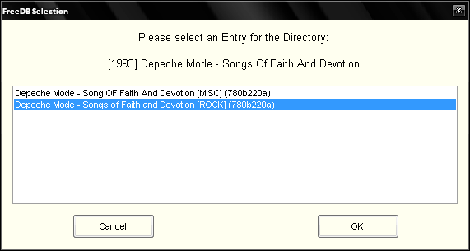

Note: This function works only pretty well, if the Record is properly ripped. The DiscID and the
query string are calculated from the count, duration and order of the songs. The calculation needs
the exact durations of all the songs down to milliseconds. If one or more of the songs are not
exactly ripped, this function will fail.

3.2.6 Embedding Images

You can also store images that are included in the Record Directory into the tags of the Songs. This is useful, if you want to see the images in several music player (who supports this functionality) while playing the song.
Just Right-Click on the Picture you want to embed and select “Store Image in Tags”.

When done, the image will be embedded in the tags of all music files in the same directory.

3.2.7 Extracting Images

If you got no Picture in your Record Directory, but your songs contain images, you can also Right-Click on one of the songs and select “Extract Image to File”.

When done, the image will be saved within the Record Directory and will be named after the Record Artist and Record Title.

Note: This function is still buggy, sometimes External GDI Exceptions are thrown, so it might be that this function wont work.

3.3 Filter

If you read a really large collection, you might search for Records with special properties. Maybe you are looking for all Records in your Collection, that have a Bitrate higher than 256 Kbps. Or you might search for Records from Artist XY, or you might also want to see the Records from Label XY.
All those search conditions can be set in the Filter Dialog.

In this example, you see a Collection, that is sorted by Artist. I looked for all Releases from Steve Bug from 2000 till 2005 that have a Bitrate between 300 and 350 Kbps and a duration between 10 and 30 minutes.

Note: Artist & Label textfields are case sensitive, so the text have to match exactly with the RecordArtist or Label of the Record Tag.

The checkbox “Copy only Filtered Records” gives you the possibility to copy only those selected Records, if you want to copy a whole Collection.

3.4 Save Collection

You have the possibility to save your collection in a file. You can choose between following formats.

- TXT

If you want to save your Record Collection information in a text-file, the specified File Structure
in the Settings define the syntax for each line. For example, if the File Structure is define like

[%YEAR] %RECORDARTIST - %RECORDTITLE (%BITRATE)

the outcome in the file will be like this.

[2006] Octave One - Off the Grid (256)
[2006] SCSI-9 - The Line of Nine (192)
[2007] Calibre - Musique Concrete (320)
[2007] Claes Rosen - Walking Forward EP WEB (320)
[2007] Dartriix - Dartriix (320)

So you are able to create whole lists of your Collection.

- HTML

Another nice feature is to save the Collection as html. The syntax is fixed (for the moment).

- XML

You can save it in a xml-structure, too. Maybe you want to process on your Collection
information with another tool.

3.5 Copy Song / Record / Collection

By Right-Click on the Song-, Record- or Collection-Node you see the Copy Function. By clicking, the selected item will be copied to the Destination Directory, that is specified in the Settings. All files to copy will be renamed by the File Structure.

Note: If you choose to copy your Collection, only those Records will be copied, that has fulfilled tags. Otherwise, TagMotion cannot rename the files.

3.6 Delete File / Record

By Right-Click on the Song-, Picture-, Info- or Record-Node you see the Delete Function. By clicking, the selected item will be deleted from disc.

Note: If you delete an item, it will NOT be moved to the Recycle Bin. So use with care, you should always know what you are doing.

4.0 SUMMARY

Summary

TagMotion was very helpful for me to organize my Music Collection and keep it clean and manageable. The Software has been developed by chrismo in 2008/2009.
If you find any bugs or you have any recommendations, just let me know.

The software is provided “AS IS” and there are no warranties or implied warranties. The developer is not liable for any special, direct, indirect or consequential damages or any damages whatsoever resulting for any reasons out of the use or performance of this software.



